HW 4

Question 1: for the given image and structuring element perform the following morphological operations

* Erosion of A with B
* Dilation of A with B
* Opening of A with B
* Closing of A with B

A=

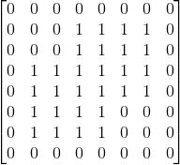

And the structuring element B is defined as

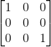

Calculate Erosion of A with B

Calculate Dilation of A with B

Question 2 :

For the image shown below we are supposed to compute the Gaussian and Laplacian Pyramids



Figure 1

The Laplacian and Gaussian Puramids are as follows:

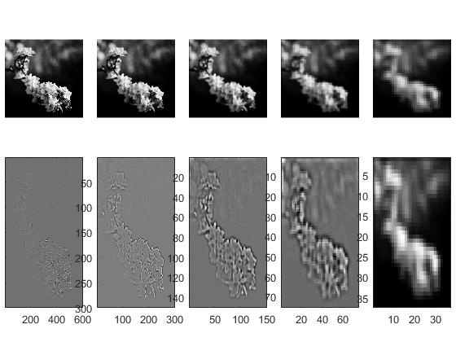

Question 3

Question 4

For this question we were supposed to implement the speeded-up version of the mean shift clustering algorithm. The results of this algorithm on the given dataset for different bandwidths r=1,2 and 4 are shown below.

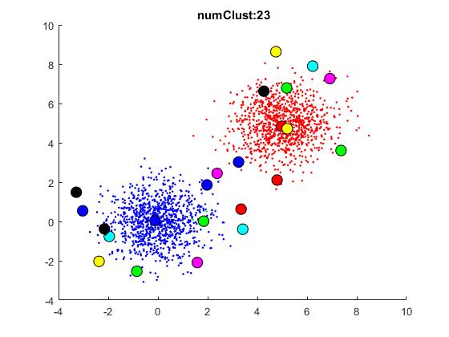

Figure 2:Mean shift clustering for r=1

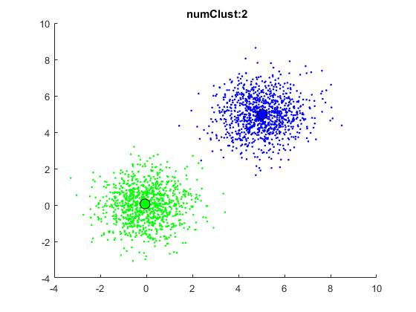

Figure 3:Mean shift clustering for r=2

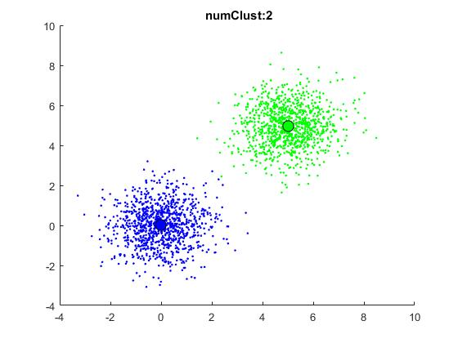

Figure 4 Mean shift clustering for r=5.

Question 5:

The results for mean shift segmentation on sunset.bmp and terrain.bmp for r=7 and r=10,along with the affects of including and not including spatial information are also included.

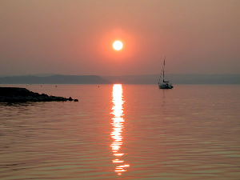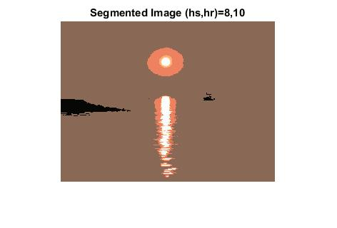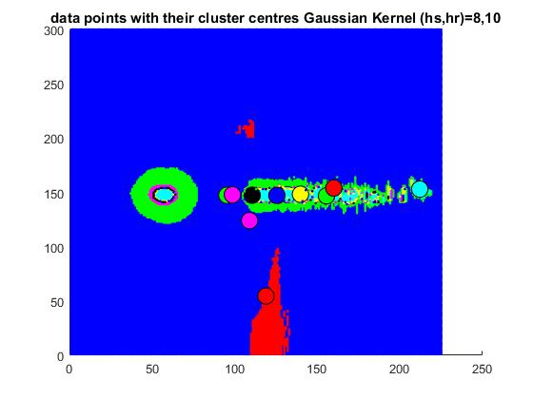

Figure 5: Segmentation results for Sunset

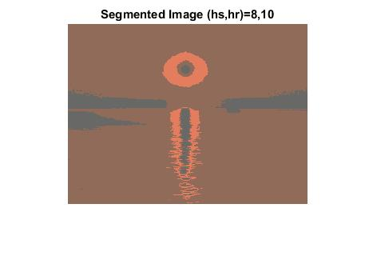

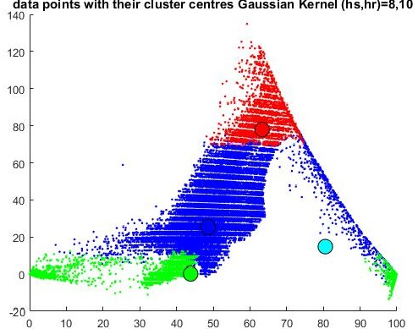

Figure 6:Sunset Segmented without including spatial information.

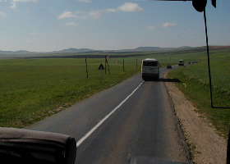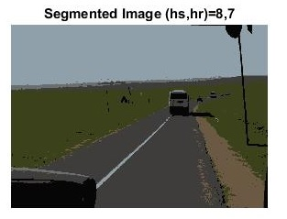

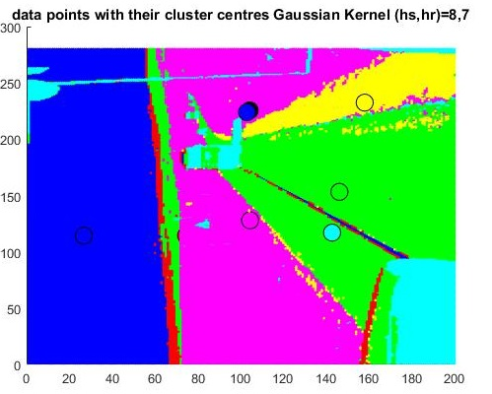

Figure 7:Terrain segmented at bandwith =7.

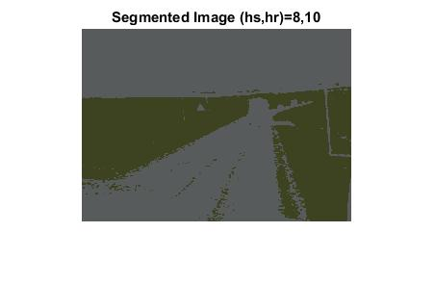

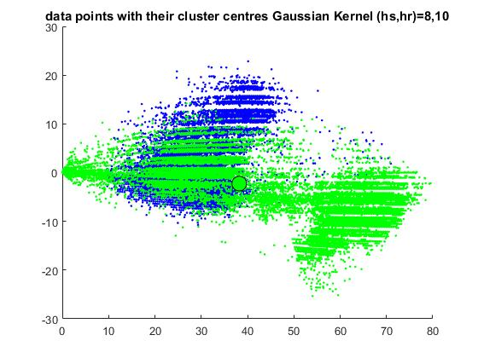

Figure 8:Segmentation results for terrain without spatial information

The mean shift segmentation algorithm that we computed relies upon the choosing the correct parameters. The range parameter hr along with another parameter will determine the number of regions in which the image will be segmented. Also, it may be tempting at first to choose a high value of r say 15 but then this will result in over segmentation. Which is quite evident from the segmentation results for terrain,bmp where r was set to 10.

On the other hand, if we choose a low value say 5 then not only will this result increase the time taken to segment the image (which consists of approximately 67500 pixels!) but also the resolution will not be clear thereby leading to an under segmented result.

The most appropriate value was found to be 7 which resulted in a perfect result. This is evident from segmented versions of both sunset and terrain as shown above.

Another interesting thing to note is that overall result is dependent on whether we include the spatial information or not. Including spatial information will result in a richer feature pallet which consists of all the important colors in the image. This is quite evident from the clustered plots shown in Figures 5 and 7.

But if spatial information wasn’t considered then the resulting feature pallete will be broken into several smaller components which effects the resolution.